**C++ Programming**

Simply Easy Learning

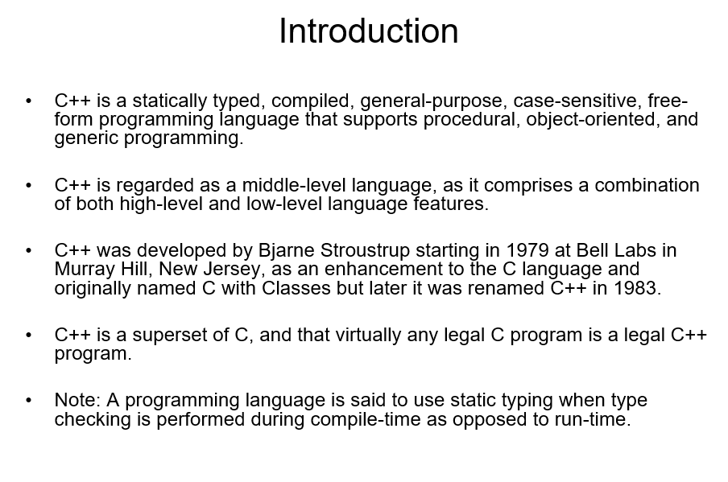

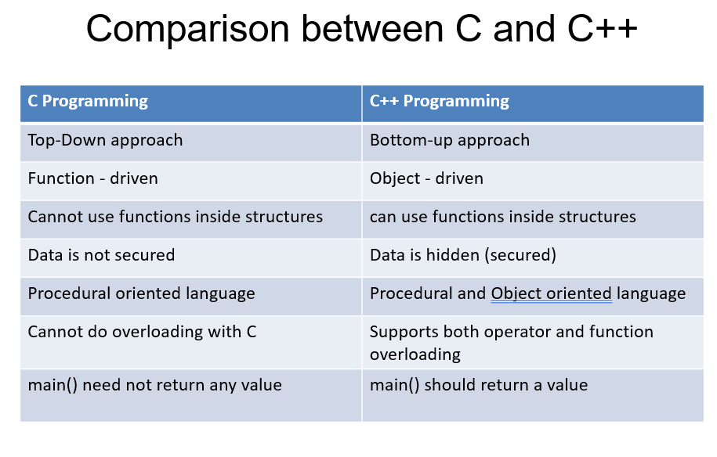

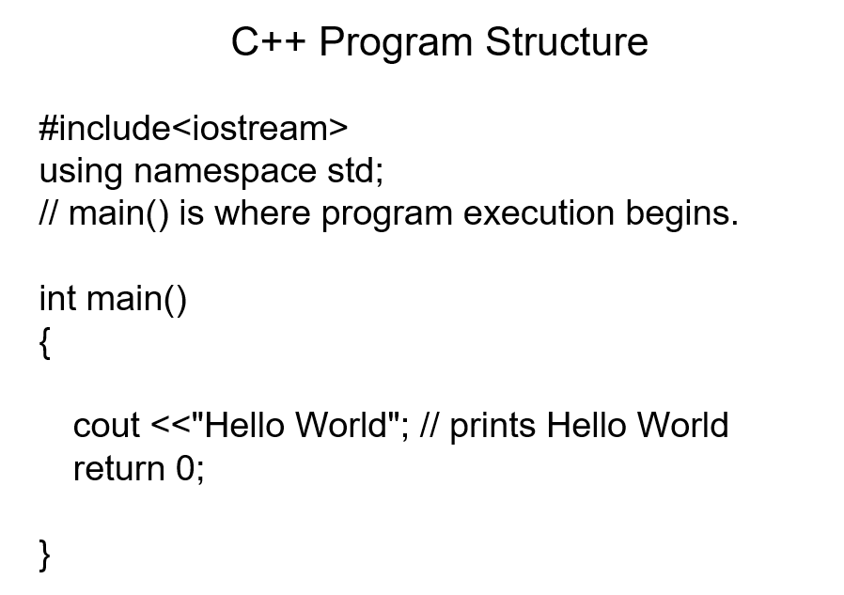

Let us look various parts of the above program:

• The C++ language defines several headers, which contain information that is either necessary or useful to your program.

For this program, the header <iostream> is needed.

• The line using namespace std; tells the compiler to use the std namespace. Namespaces are a relatively recent addition to C++.

• The next line // main() is where program execution begins. is a single-line comment available in C++. Single-line comments begin with // and stop at the end of the line.

• The line int main() is the main function where program execution begins.

• The next line cout << "Hello World"; causes the message "Hello World" to be displayed on the screen.

• The next line return 0; terminates main( )function and causes it to return the value 0 to the calling process.